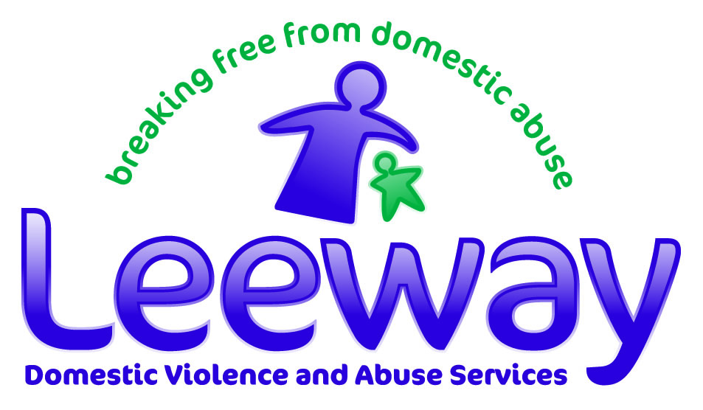

Volunteer Application Form
Thank you for considering giving your time to Leeway. Before completing this form, please ensure you have checked to see the current opportunities we have available via our website. (Work with Norfolk and Suffolk’s Largest Domestic Abuse Charity (leewaysupport.org) Please complete all questions as fully as you can. This application form is part of our volunteer recruitment process. If you need help or have questions, please contact us on 0300 561 0077.

Your Details

First Name: | Last Name:
Phone Number: | Mobile Number:
Email Address: | Full Address:

Which volunteer role/s are you interested in?

Why are you interested in volunteering for Leeway?

Do you have any health issues or other needs that you feel we could support you with when volunteering? Or do you have any concerns about volunteering? This information will be treated as strictly confidential.

Skills and Experience

What previous personal/voluntary/professional experience and current skills or qualifications do you have that may help you in the role you have applied for?

Please tell us what you know about domestic abuse:

Please indicate your general level of competence using a computer (if your role will require computer use)

Please highlight: 0 1 2 3 4 5 (0 = I can't use a computer / 5 = Confidently competent)

Is there any additional information you would like us to know?

Availability

Please indicate when you would be available to volunteer (days/times):

Emergency Contact
We would only contact the person you nominate in an emergency.

Full Name: | Relationship to you:
Phone Numbers (home and mobile): | Email Address:

Referees
Please give details of two people (not relatives/friends) who have known you for over a year and could provide a reference. At least one referee should be professional - a current or previous employer/volunteer manager/teacher or other independent person. All volunteers are accepted subject to satisfactory references and Leeway will apply for these direct before interview stage. If you can’t provide two references for any reason, please state this.

Referee 1 | Referee 2
Full Name: | Full Name:
Email Address: | Email Address:
Phone Number: | Phone Number:
Full Address: | Full Address:
Relationship to you: | Relationship to you:
How long have you known this person? | How long have you known this person?

Other Information

Would you be prepared to travel a short distance, for example to a service users home (if applicable to volunteer role), if they live slightly outside your immediate area? (travel expenses can be paid). Please tick:

- Yes, I have access to a car and could travel
- Yes, I could use public transport
- No

How did you hear about volunteering for Leeway? (Please tick):

- Leeway website  - Volunteer Centre  - Do-it  - Internet search ie. Google  - Facebook  - Twitter | - Word of mouth  - Local newspaper/TV/radio  - University/college/school  - Poster/flyer  - Volunteer fair  - Other (please specify):

Declaration of Criminal Convictions
Because of the nature of the work we carry out, all volunteers will need to have a Disclosure and Barring Service (DBS) check. If you have any criminal convictions SPENT or UNSPENT (currently or in the past) you must disclose those convictions.

If you are applying for an exempt volunteer post i.e. a volunteer post which involves substantial access to children and vulnerable clients you must disclose all criminal convictions regardless of the nature or the sentence or the time of the conviction.

Please answer the following questions:

Do you have or have had any criminal conviction(s)?

- Yes
- No

If you have said yes please give details (It may not necessarily affect your application to volunteer, depending upon the circumstances):

In the last 2 years have you received a service from a domestic abuse support organisation?

- Yes - Please give the date: Organisation:
- No

In the last 2 years have you had any police involvement due to domestic abuse?

- Yes - Please give the date:
- No

I confirm that the information I have given on this application form is correct and complete and any false statements or omissions may result in any volunteering at Leeway being terminated.

I understand and agree that the data contained in this application form will be used for volunteer recruitment purposes and will be held on a secure computer database in line with Data Protection and Confidentiality Policies.

Full name: | Signature:
Date:

Please send your application form in an envelope marked ‘confidential’ to:
Volunteer Recruiter, Leeway Domestic Violence and Abuse Services, PO Box Leeway, City Hall, Norwich, Norfolk NR2 1NH Or email/scan to: admin-volunteer@leewaynwa.org.uk
Equal Opportunities Form
Leeway wants to meet the aims and commitments set out in its policy. This includes not discriminating under the Equality Act 2010, and building an accurate picture of the make-up of volunteers in encouraging equality and diversity. We need your help and co-operation to enable it to do this, but filling in this form is voluntary. The information you provide is confidential, and can be detached from the application form and sent separately if preferred.

Date:

What is your gender identity?

- Man (including trans man) | - Woman (including trans woman) | - Other gender identity

What is your age group?

- Under 18 | - 18-25 | - 26-34 | - 35-44
- 45-54 | - 55-64 | - 65+ | - Prefer not to say

How would you describe your ethnic origin?
- White British | - Mixed White and Black African
- White Irish | - Mixed White and Asian
- White Scottish | - Mixed Other
- White Welsh | - Black or Black British Caribbean
- White Other | - Black or Black British African
- Asian or Asian British Indian | - Black or Black British Other
- Asian or Asian British Pakistani | - Chinese
- Asian or Asian British Bangladeshi | - Prefer not to say
- Asian or Asian British Other | - Other ethnic group:

Do you consider yourself to have a disability or health condition?

- Yes | - No | - I don’t know | - Prefer not to say

What is your sexual orientation?

- Heterosexual  - Bisexual | - Gay woman/Lesbian  - Prefer not to say | - Gay man  - Other:

What is your religion or belief?

- None  - Jewish  - Other: | - Buddhist  - Muslim | - Christian  - Sikh | - Hindu  - Prefer not to say

